Bunny Cart Performance Testing

**Test Plan:**

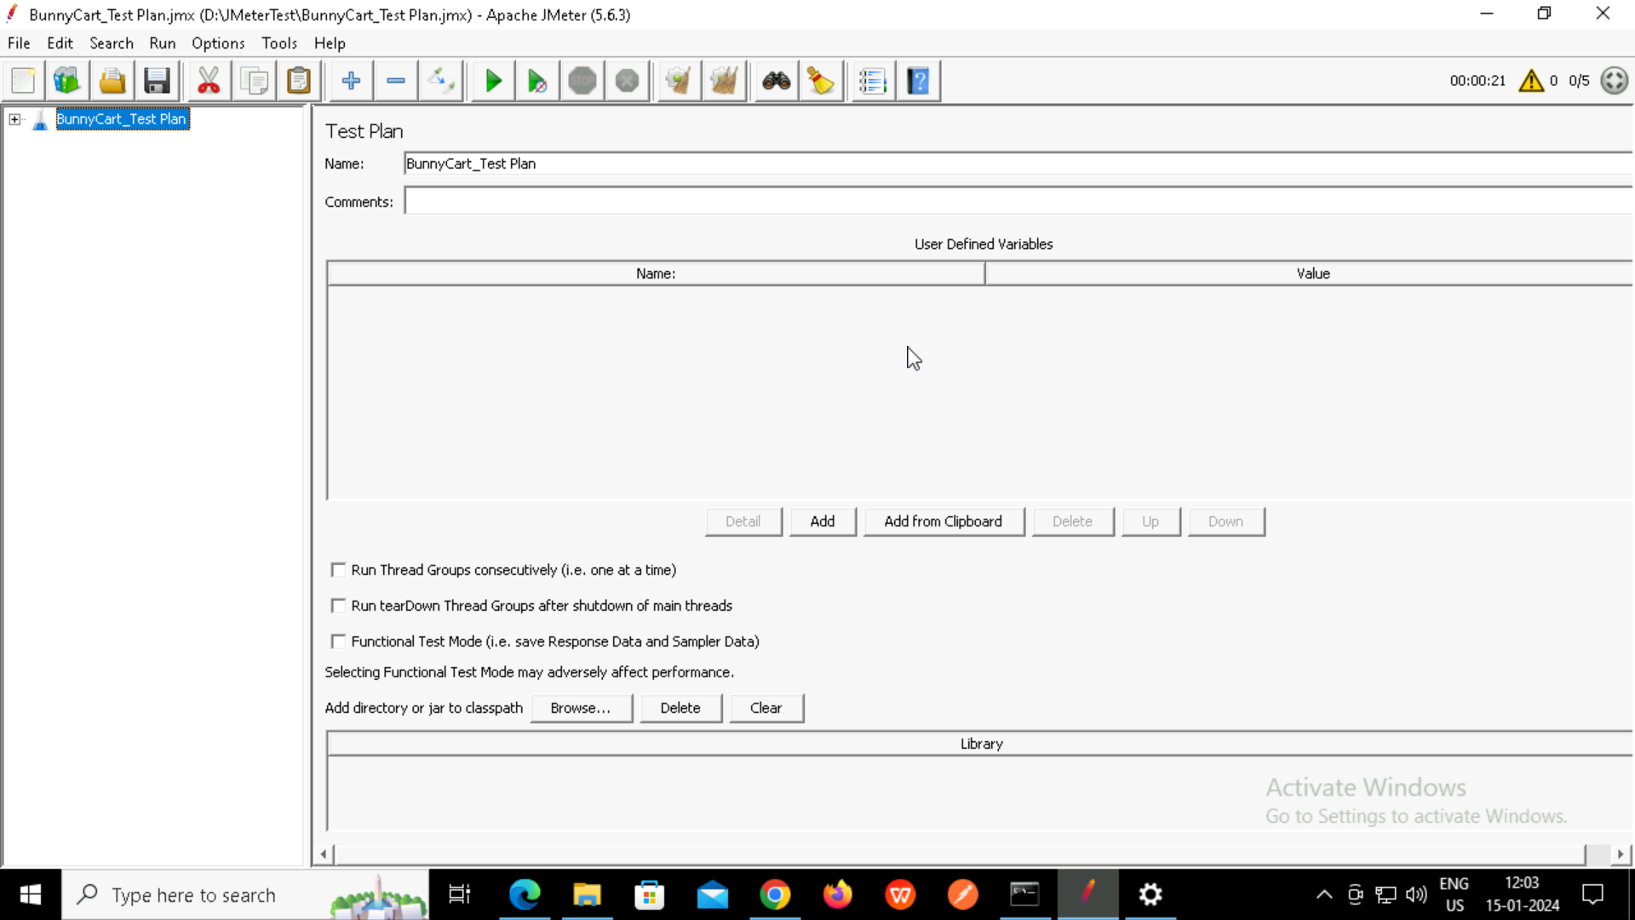

**Home Page HTTP Request Sampler:**

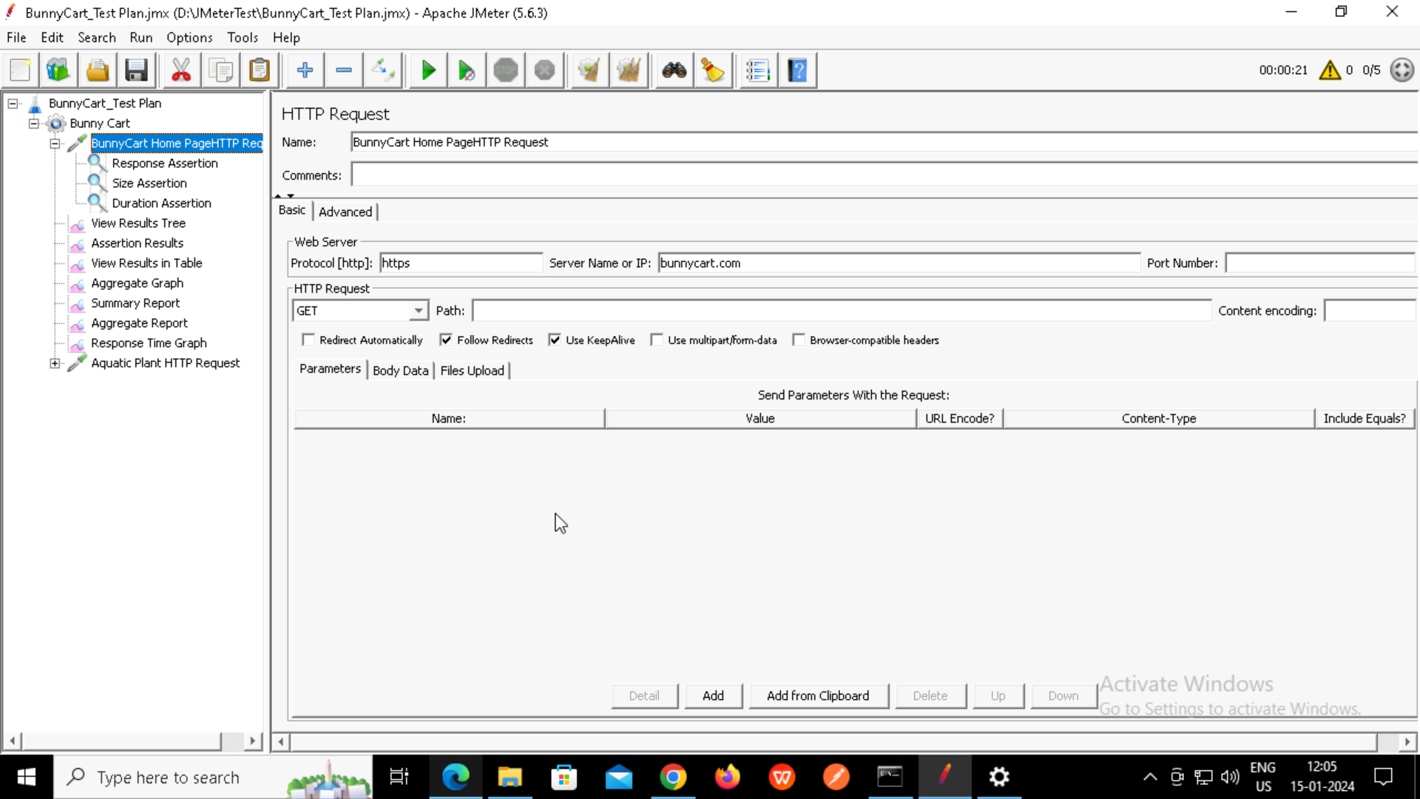

**Response Assertion:**

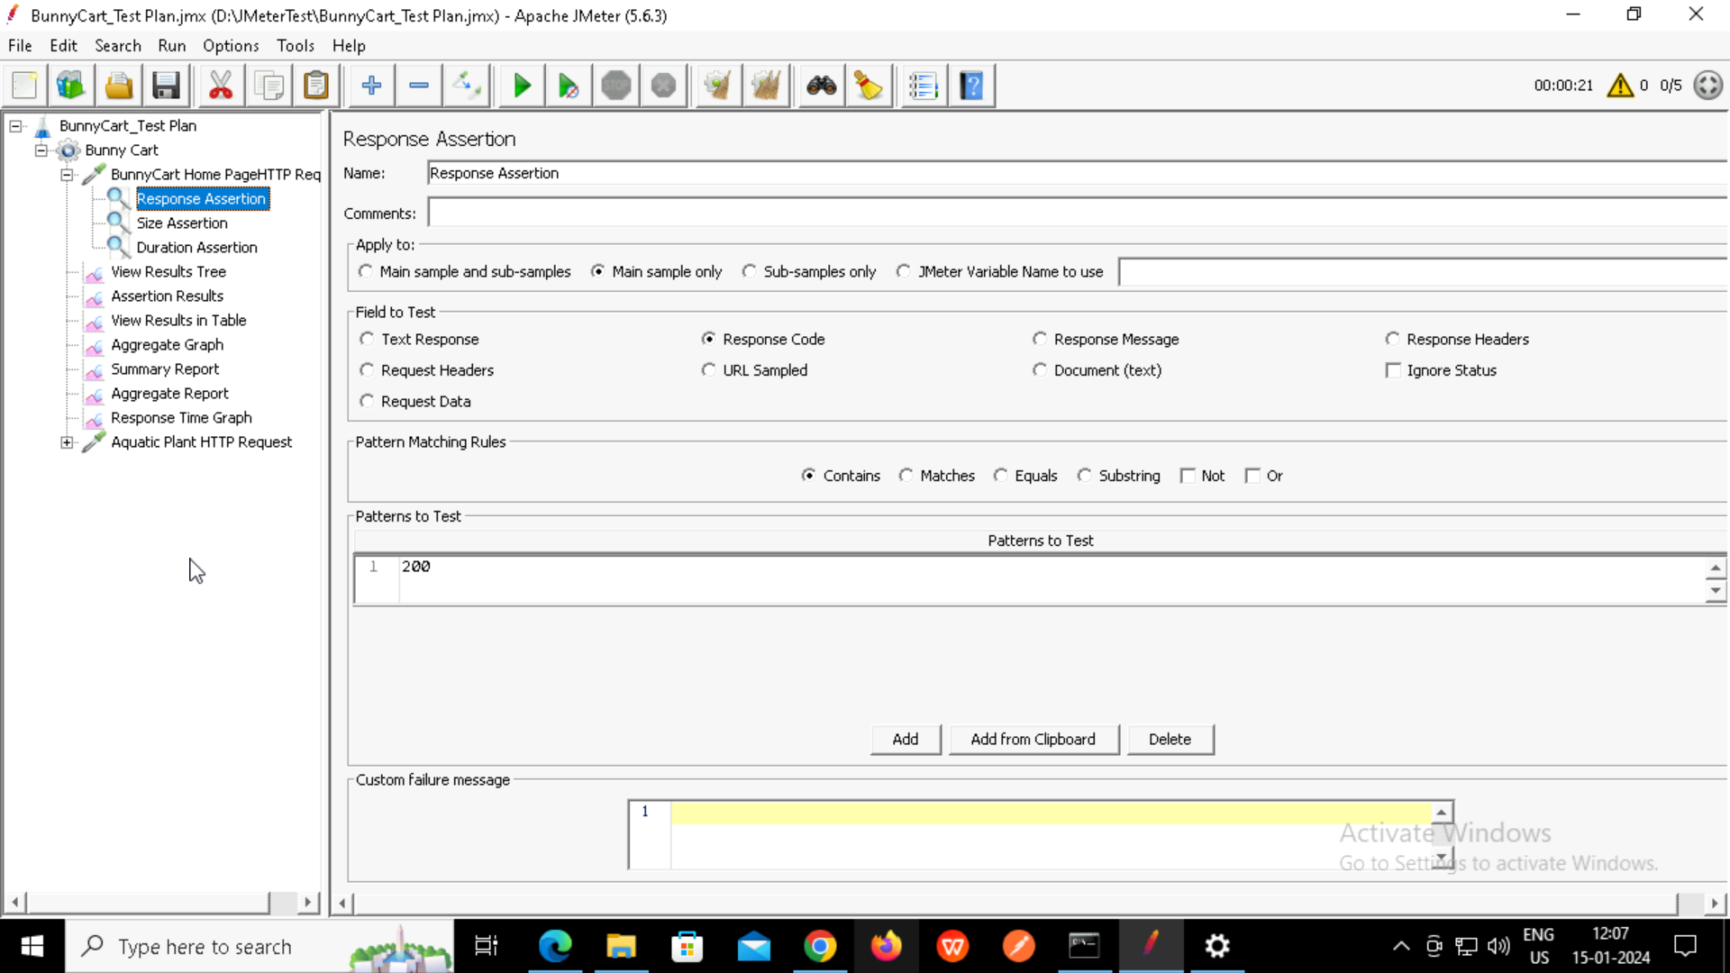

**Size Assertion:**

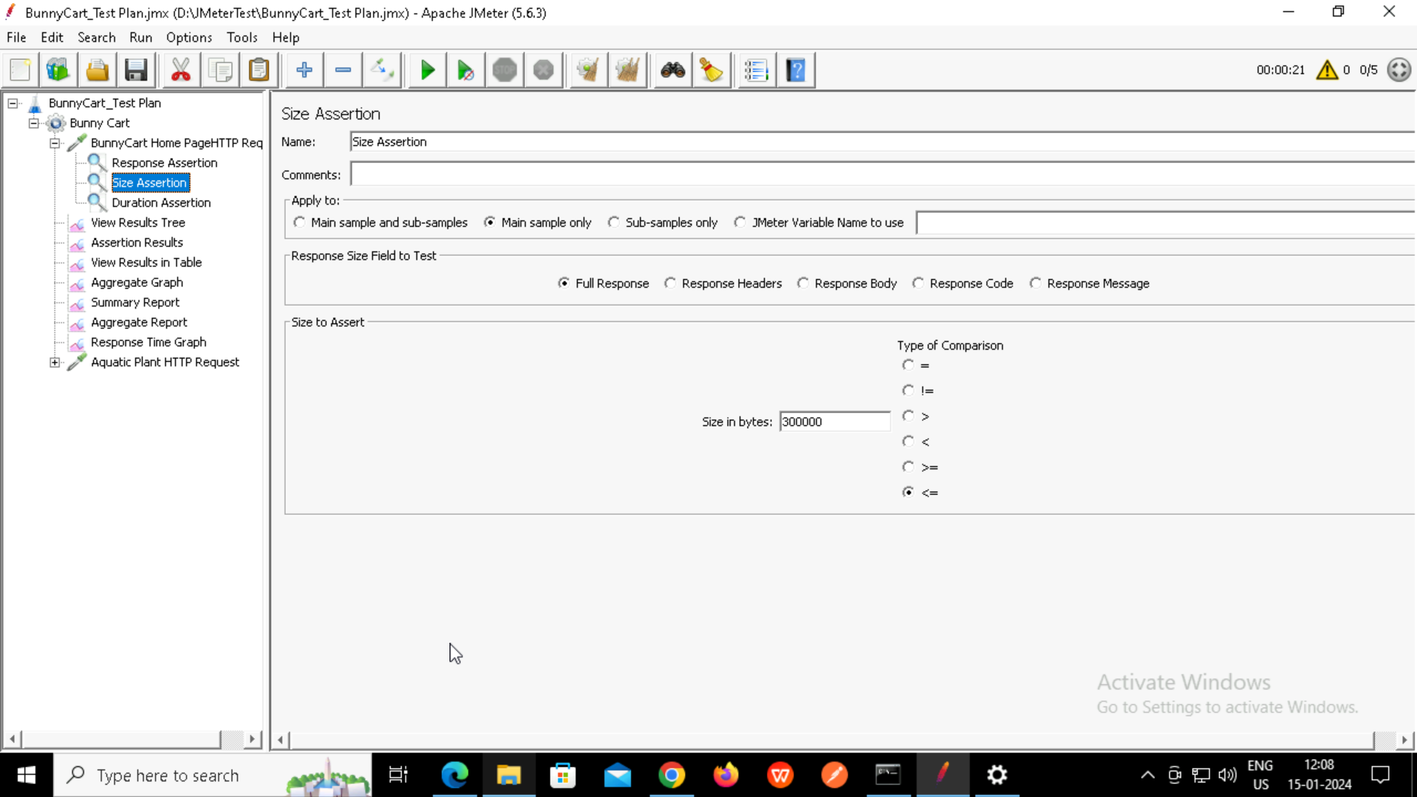

**Duration Assertion:**

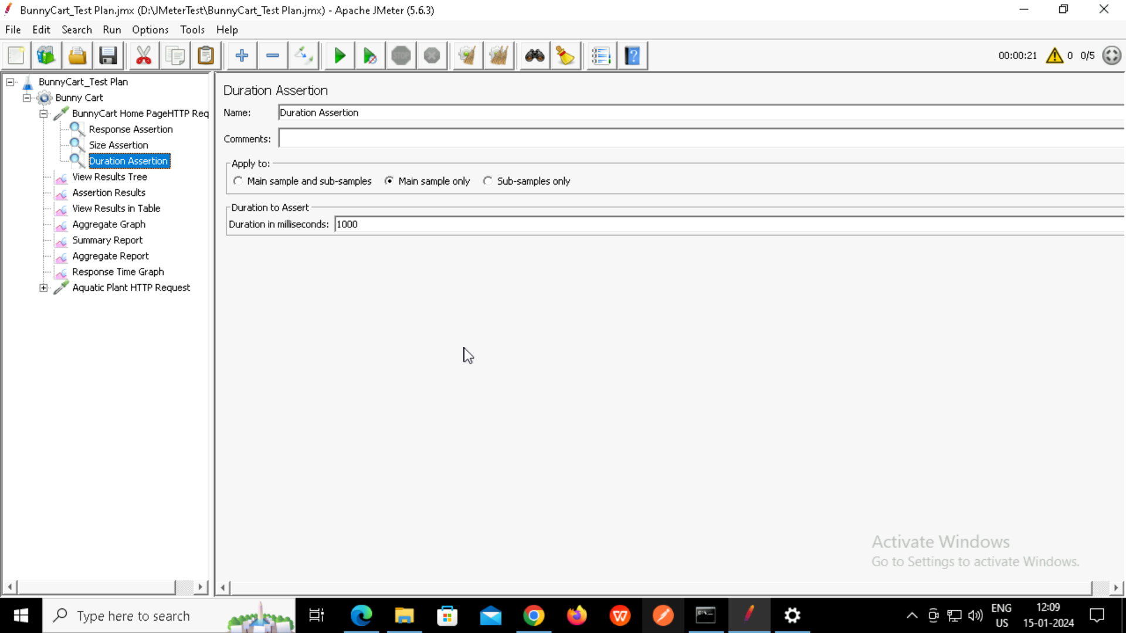

**View Result Tree:**

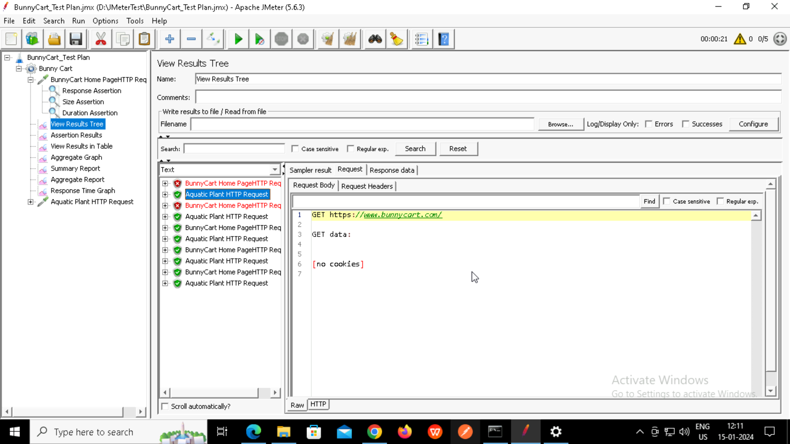

**Assertion Results:**

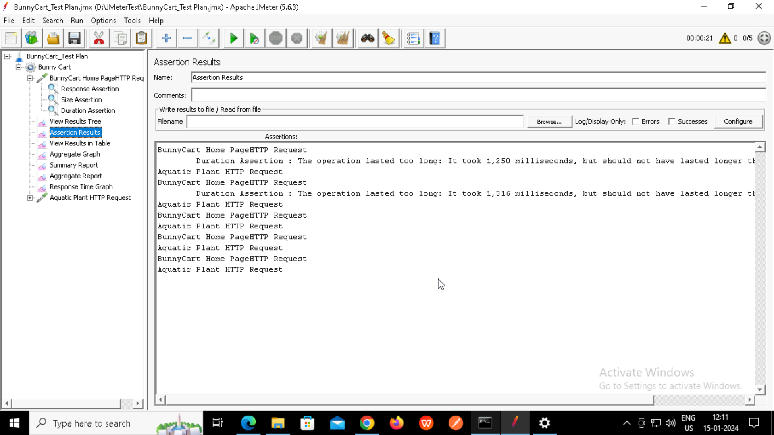

**View Results in Table:**

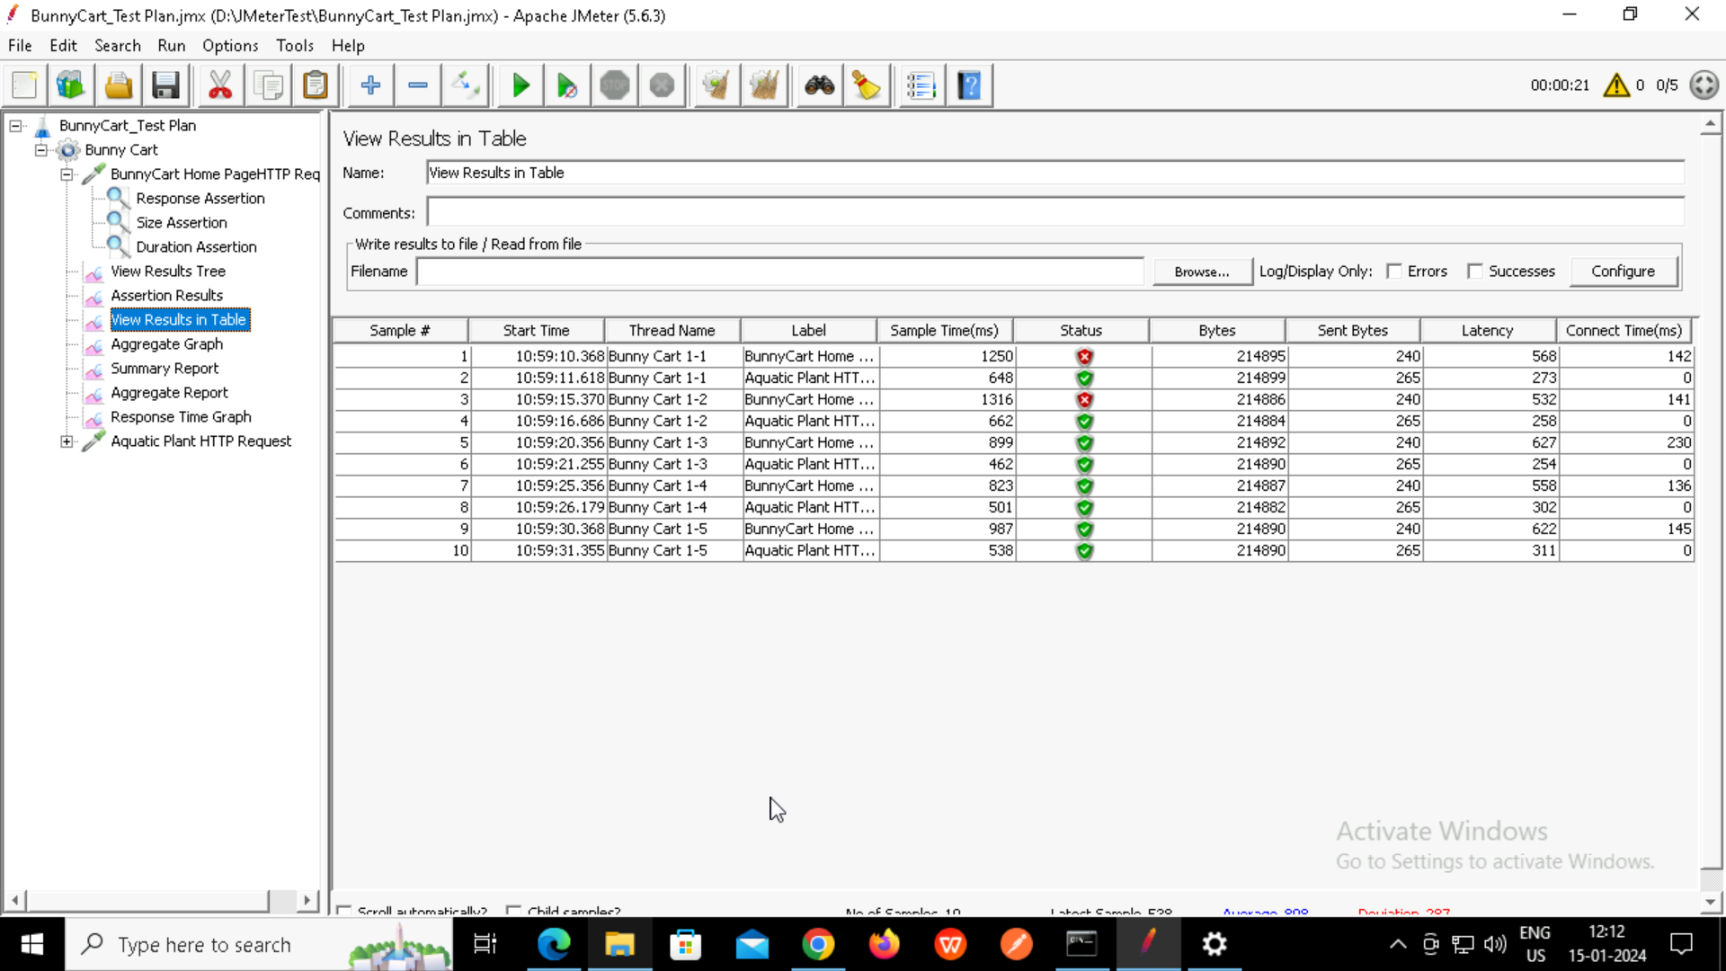

**Aggregate Graph:**

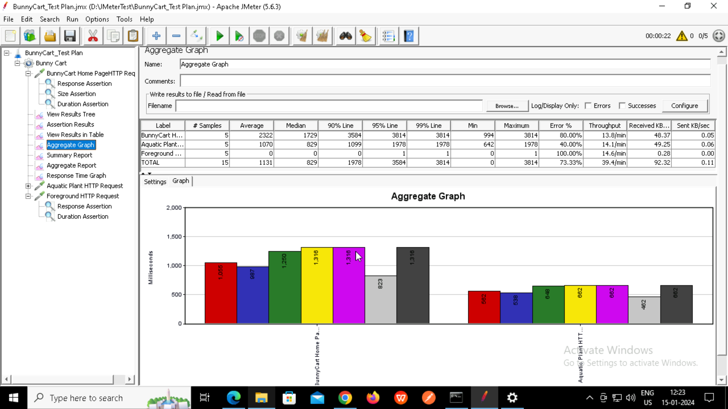

**Summary Report:**

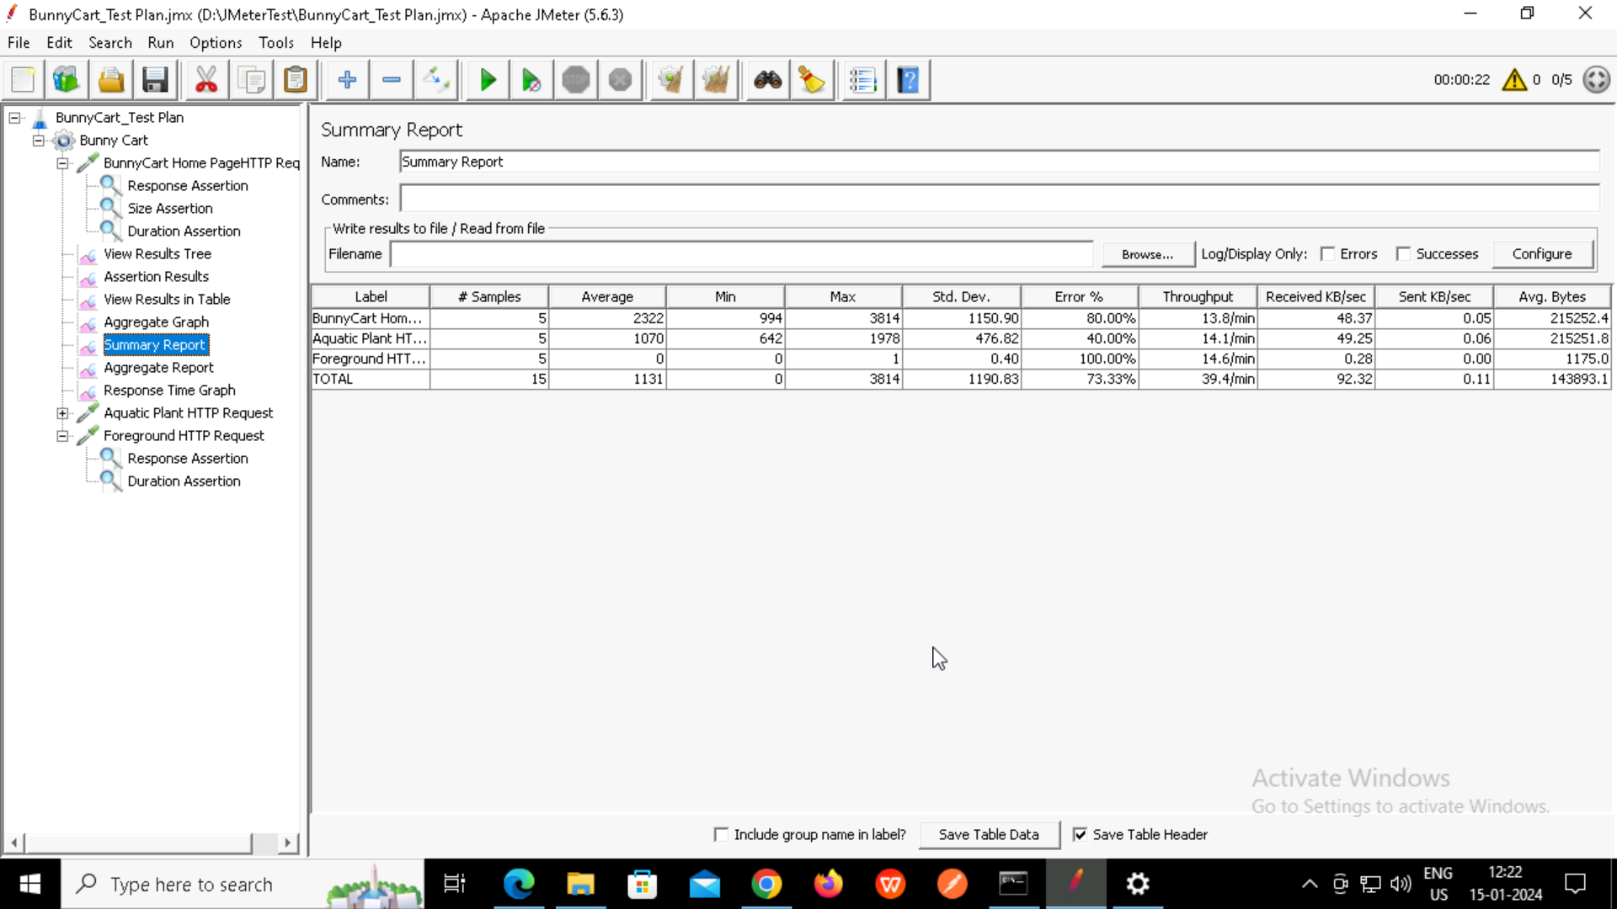

**Aggregate Report:**

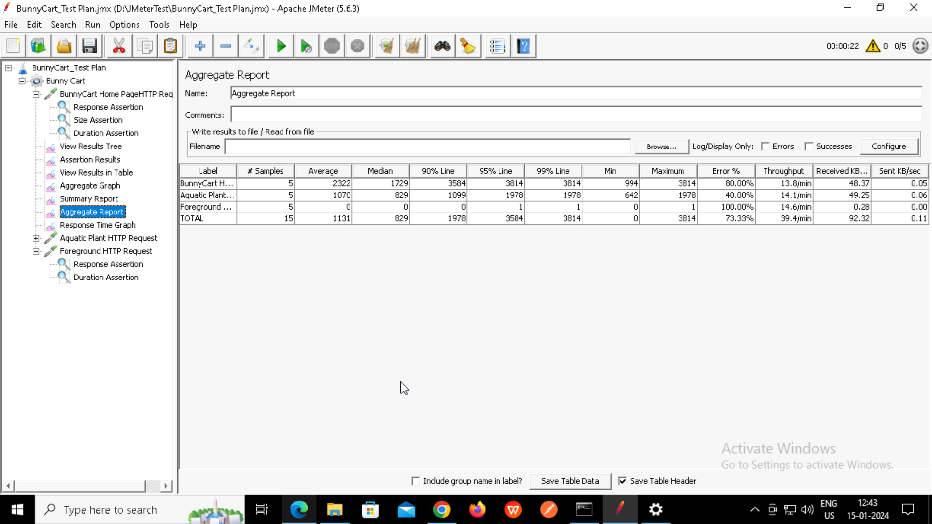

**Response Time Graph:**

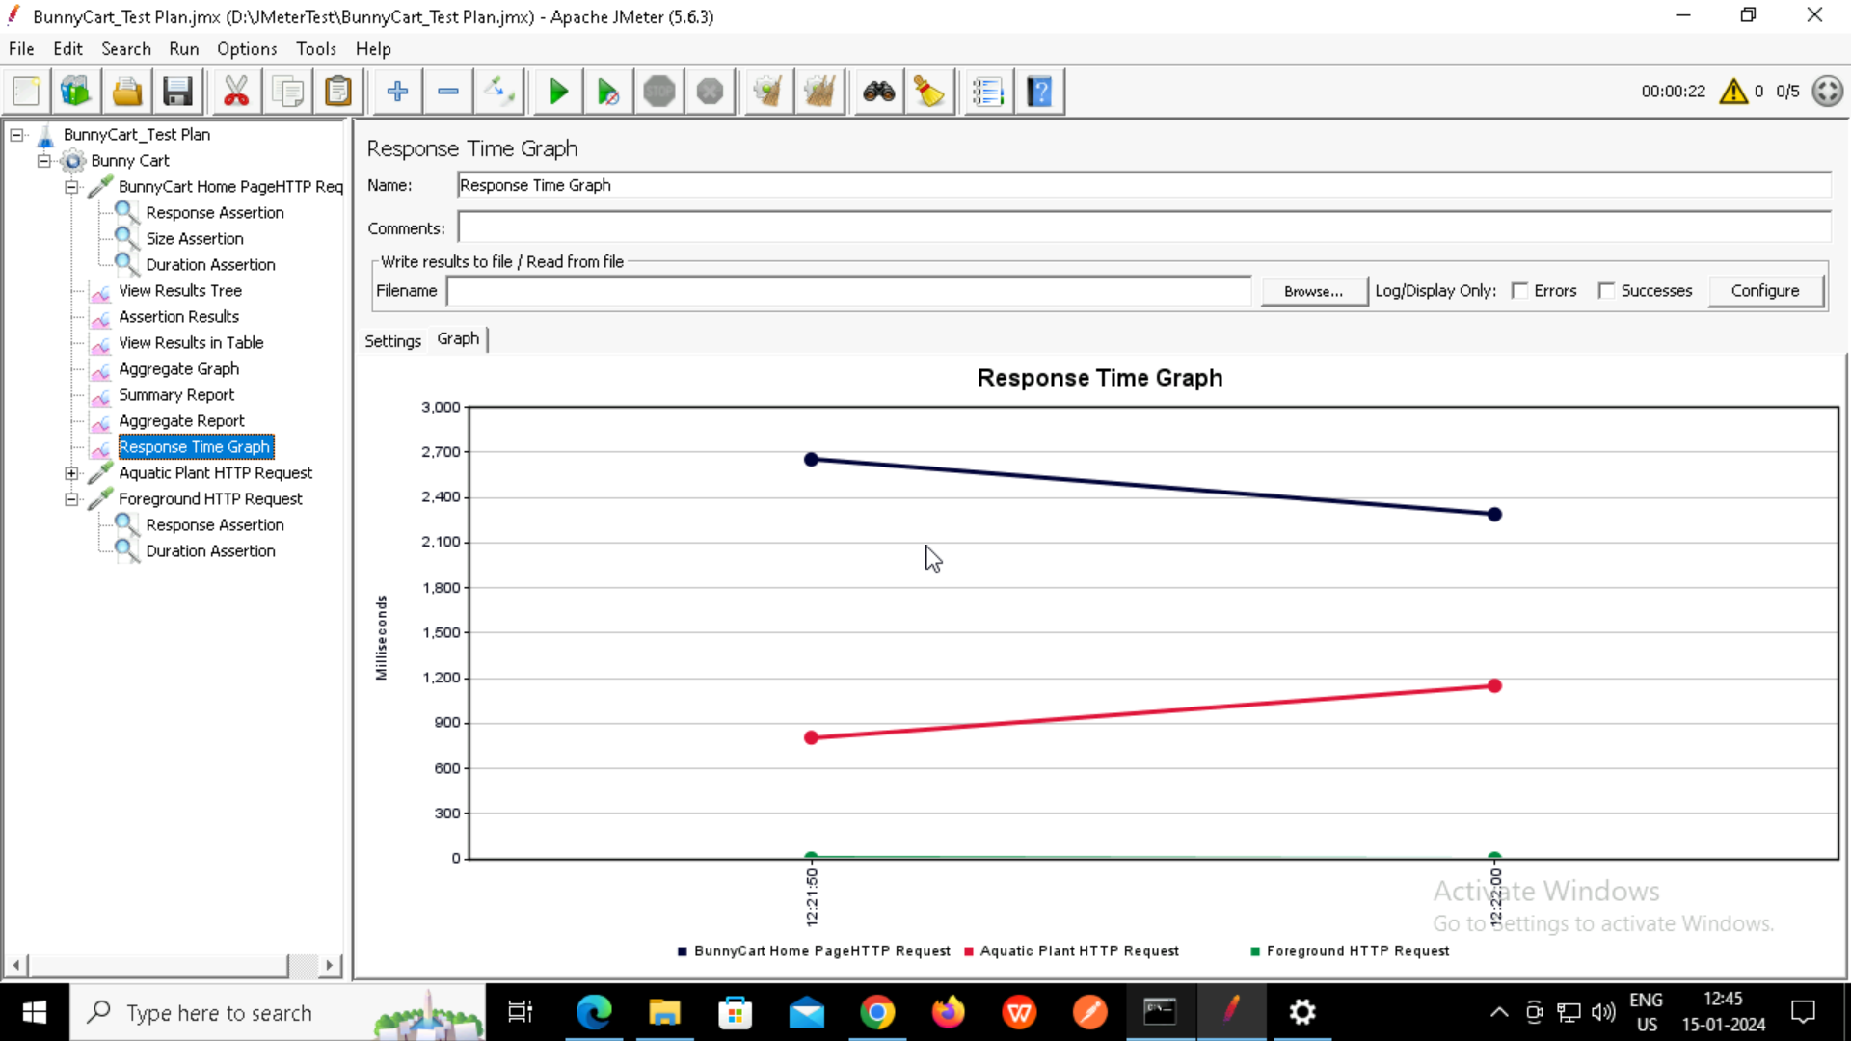

**Aquatic HTTP Request:**

**Response Assertion:**

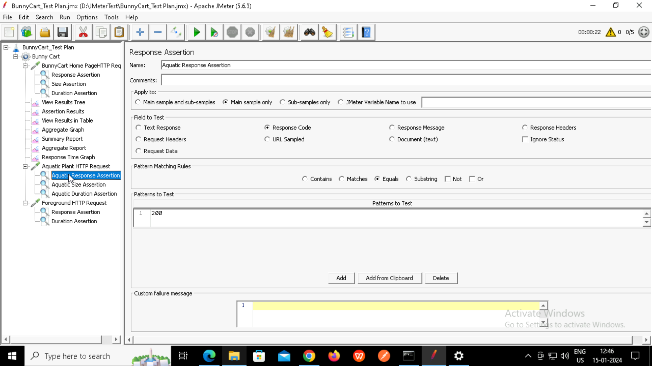

**Size Assertion:**

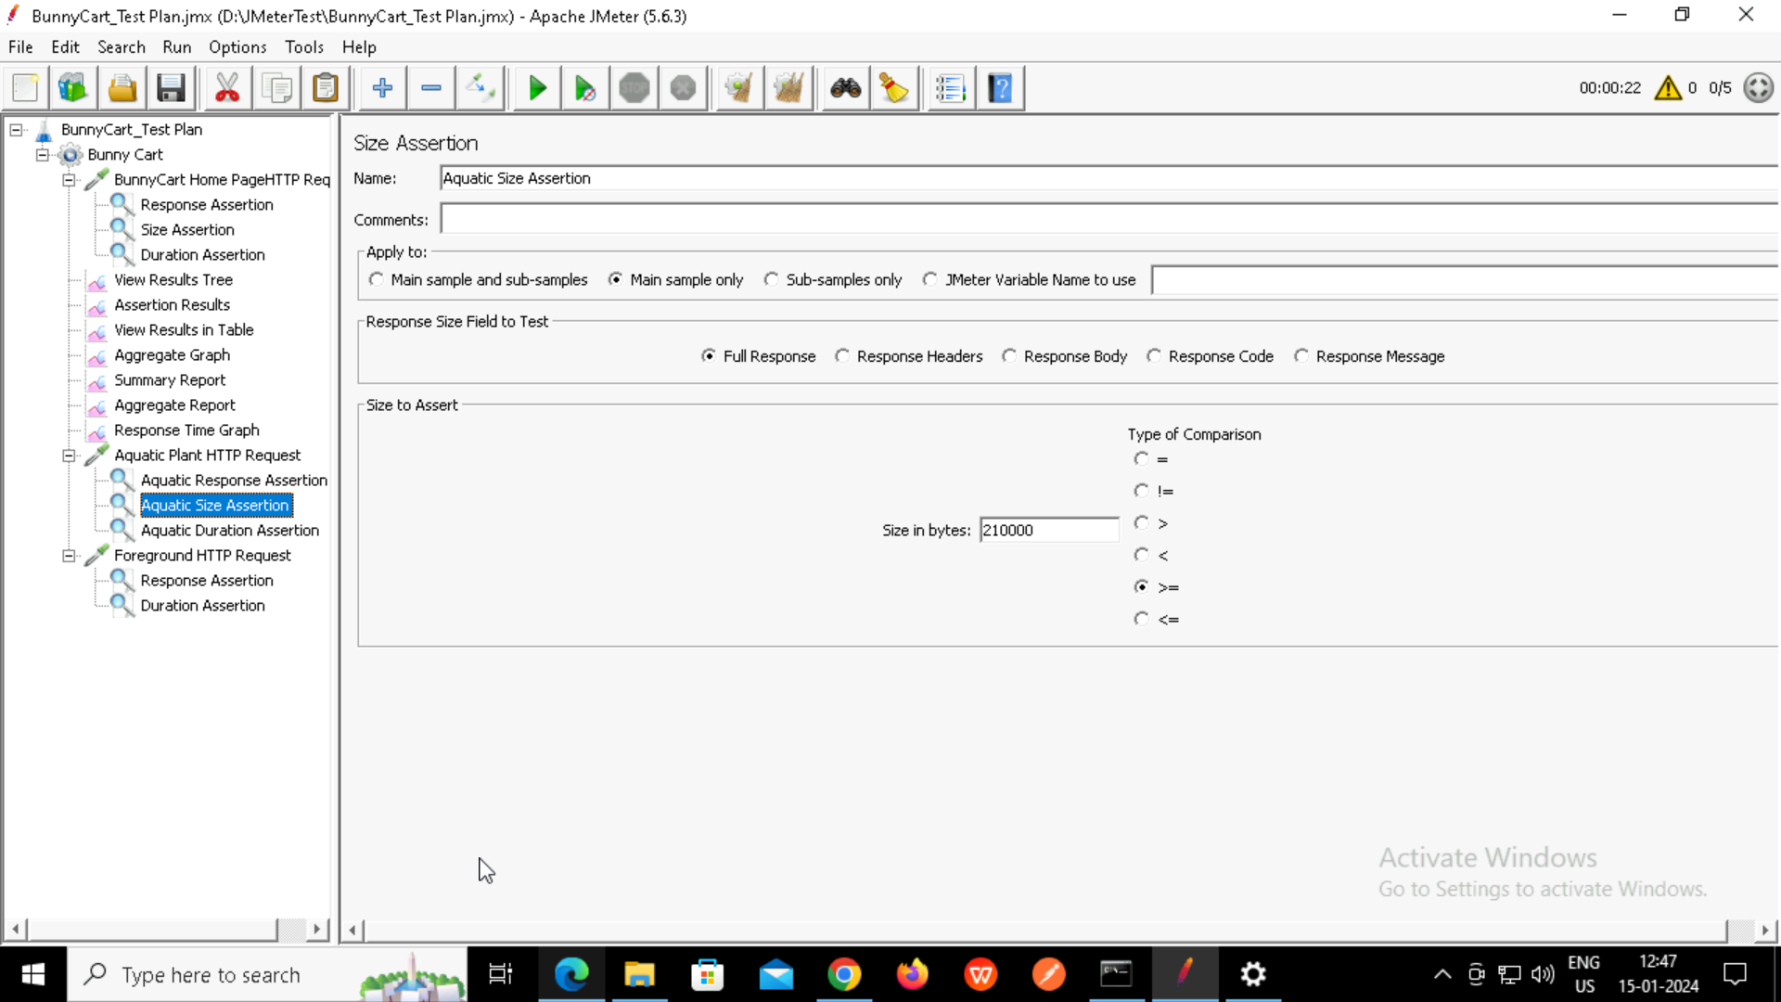

**Duration Assertion:**

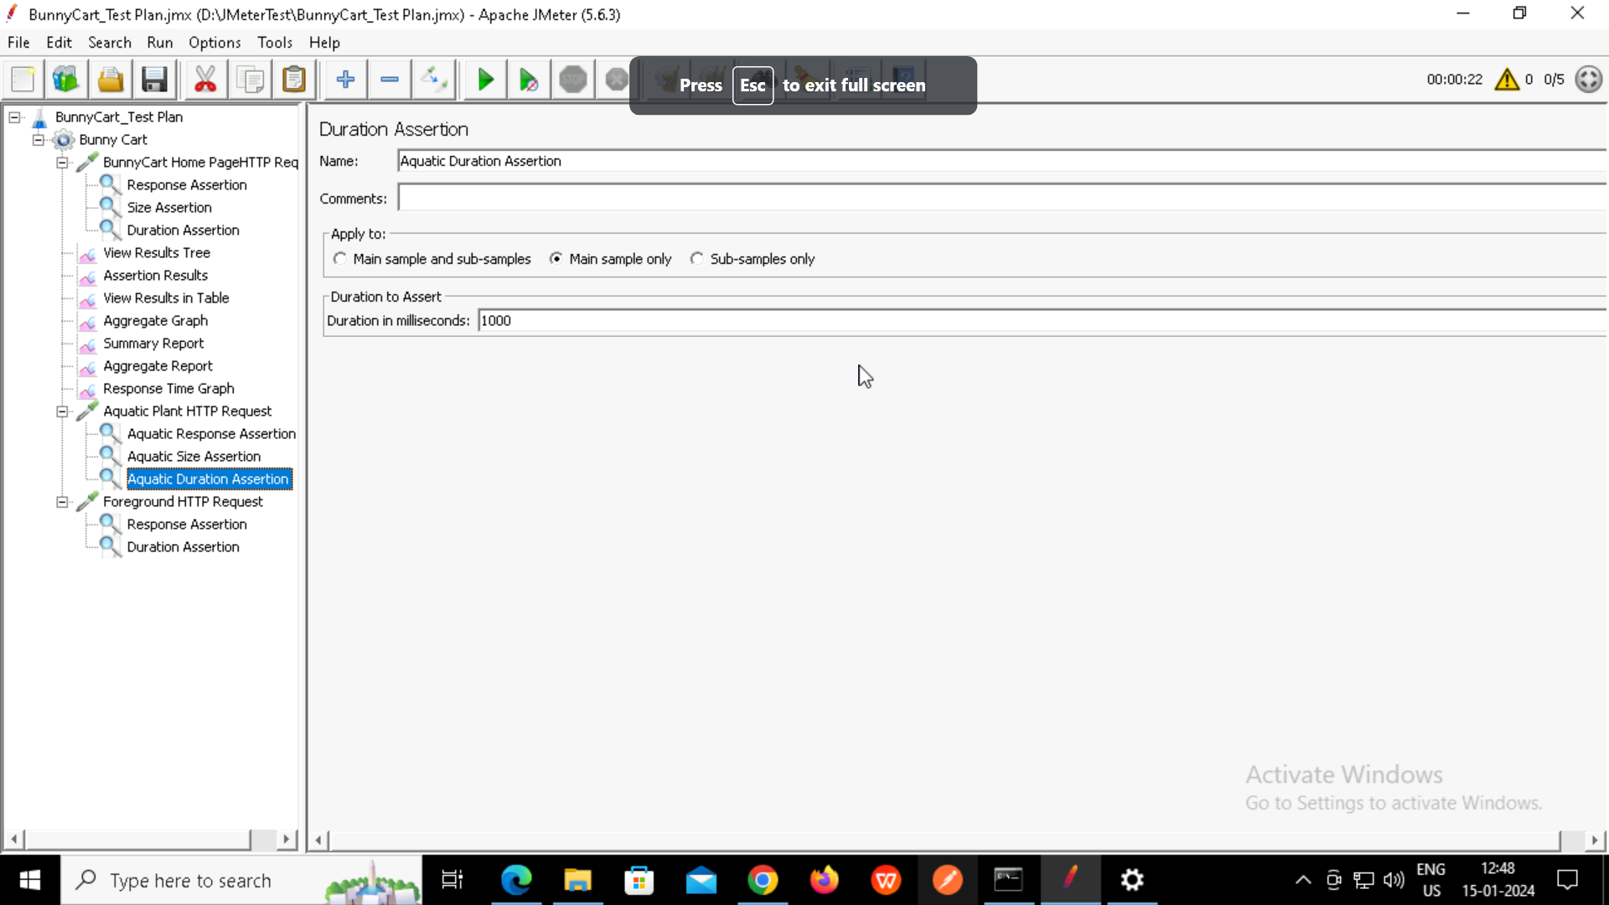

**1)Average Time Response for Home Page is 2322**

**2) Duration assertion failed due to response took long time.**